

Introduction to Project Management in Life Sciences
- Two-day training at Medicon Village
19-20 November,2024
A collaboration between MVIC and Katarina Lundh
Is Your Life Science Project at Risk of Failure?
Are your projects becoming more complex than expected? In life sciences, complexity is a constant challenge. Whether you're advancing new pharmaceuticals or medical devices, your expertise is rooted in research—but are your project management skills keeping up?
In two focused days, you’ll gain the skills to lead successful, efficient projects.
Led by Katarina Lundh, with over 20 years of experience managing complex R&D projects in pharmaceuticals and medical devices, you’ll learn practical tools tailored to the unique demands of life science projects and bring you to the future with help of AI.
Upgrade your skills and set your next project up for success.

Day 1
- Project and organization
- Project leader/manager – role and competence
- Stage gate process, decision points, project phases
- Planning and Governance, the role of key stakeholders
- Risk management and quality assurance

Day 2
- The People: Culture, Climate, Project Team and the Leader
- Communication, meetings and conflict management
- Tools and checklists
- Case study
- What makes winners
- How AI will transform project management – a future outlook

Dates: 19-20 November, 2024
Venue: The Spark building, The Spark 10, Scheeletorget 1, Medicon Village, Lund
Participation fee for 2 days including lunch, material, diploma: 8.600 SEK + VAT.
Please register here (https://bit.ly/pmlifescience2411). Note: limited seats!
More information or questions: uklundh@gmail.com or 070-5788371
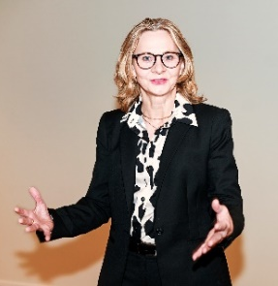
Katarina Lundh is an executive and forward leaning leader with 30+ years in life science industry, with a solid background in consumer driven product innovation and project management. She spent 23 years with Johnson & Johnson as Global R&D Director with an end-to-end global R&D responsibility for Digestive Healthcare with brands like Imodium, Pepcid and Microlax. Prior to that Katarina was head of the global Project Management Office with groups of PMs in both Sweden and US. An especially dramatic project got Katarina nominated in 2005 to the ‘Project Leader of the Year Award’, by Swedish Project Academy.

